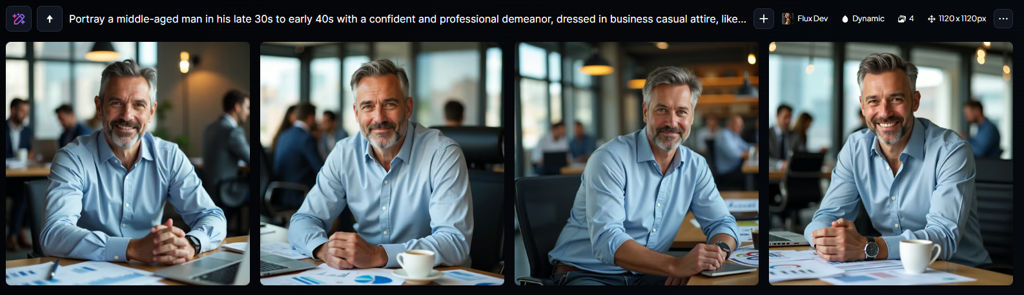

“Portray a middle-aged man in his late 30s to early 40s with a confident and professional demeanor, dressed in business casual attire, likely a button-down shirt and dark-washed trousers, sitting in a modern office setting with a cityscape or a blurred group of people in the background, with various marketing materials such as charts, graphs, and folders scattered on his desk, a laptop and a cup of coffee nearby, his facial features defined by a strong jawline, prominent nose, and a hint of a smile, with a slight stubble and a touch of grey hair at the temples, his skin tone a warm, sun-kissed beige, gazing directly at the viewer with an air of authority and expertise, conveying the sense of a successful Marketing Manager.”

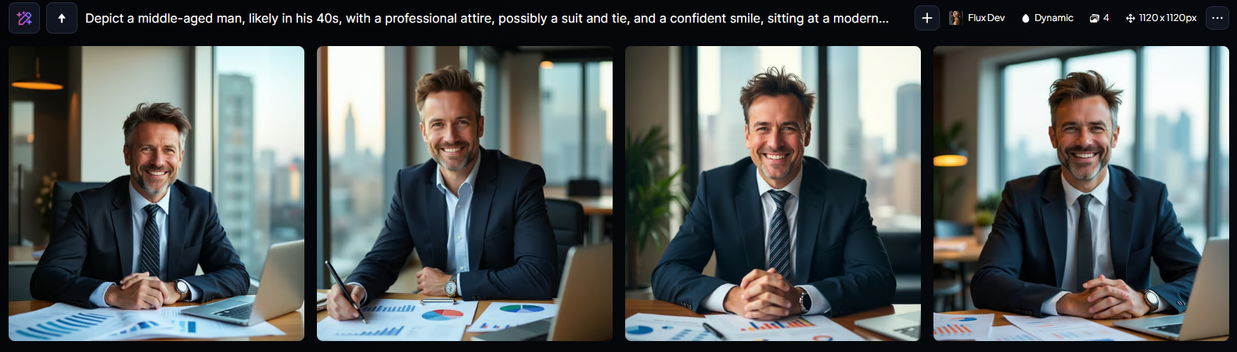

“Depict a middle-aged man, likely in his 40s, with a professional attire, possibly a suit and tie, and a confident smile, sitting at a modern office desk with a cityscape view through the window behind him, surrounded by marketing materials, graphs, and a laptop, conveying the role of a Marketing Manager, with a warm and inviting color palette, subtle shadows, and a shallow depth of field to emphasize the subject, with the man's facial features including a prominent nose, bright brown eyes, and a hint of stubble, with a fair skin tone and short, stylishly messy brown hair.”

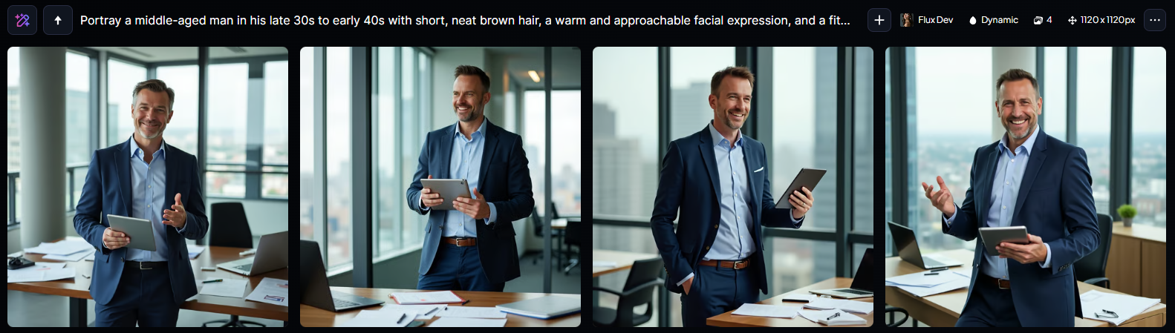

“Portray a middle-aged man in his late 30s to early 40s with short, neat brown hair, a warm and approachable facial expression, and a fit build, dressed in professional attire such as a light blue dress shirt, dark blue trousers, and a classic navy blue blazer, standing in a modern office setting with a cityscape view in the background, holding a tablet in one hand and gesturing with the other as if explaining a marketing strategy, surrounded by scattered papers, pens, and a laptop on a sleek wooden desk, with a subtle smile and a confident posture that exudes a sense of authority and expertise as a Marketing Manager.”